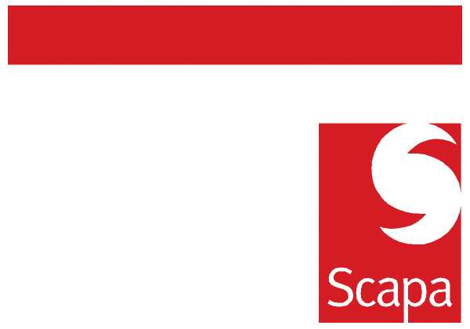

25 June 2010

GROUP CHANGE PROGRAMME
Key to our future success is Scapa’s ability to change, but in a way that aligns to the Group’s business strategy.
My own observations, supported by many of your views, indicate that we currently face a number of related issues:
- Instances where change initiatives don’t necessarily focus on the right areas.
- A perception that we try to do too much, setting ourselves unrealistic objectives.
- Often a lack of clarity over Project Executive level ownership, roles within a project and precise deliverables.
- Poor communication in terms of the current change priorities.
- A lack of metrics to monitor individual Projects.
Scapa introduced Project Management Standards last year, but we need to do more to develop our collective capability to manage change. We have therefore commenced a relaunch of the Group Change Programme. The attached short presentation provides more details, including overall Governance arrangements and the strategic initiatives within the initial Programme.
I have agreed the composition of the initial Programme with the Group Leadership Team, using inputs such as my Strategic Plan and the Group’s Risk Profile. You will notice that there is an emphasis on the development of Processes, building on the work already started around Structure and People.
Andrew Monkhouse will perform a Programme Manager oversight role in addition to his current Risk and Assurance responsibilities. He will facilitate overall programme performance reporting, help the Group Leadership Team determine the composition of the Programme and work with Project Managers to ensure that Project Management Standards are observed. Regular updates will be provided across Scapa.

Heejae Chae
Chief Executive

